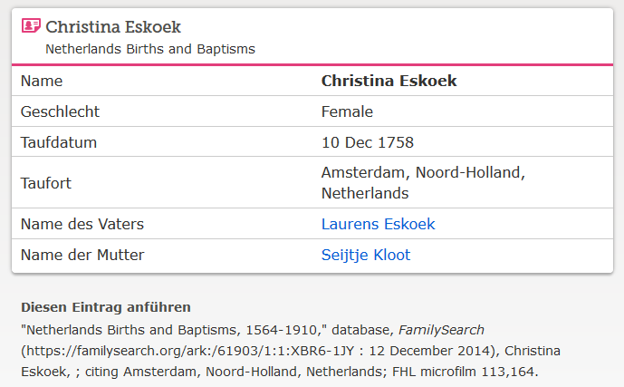

www.familysearch.org ; Christina Eskoek, Taufe 1758

