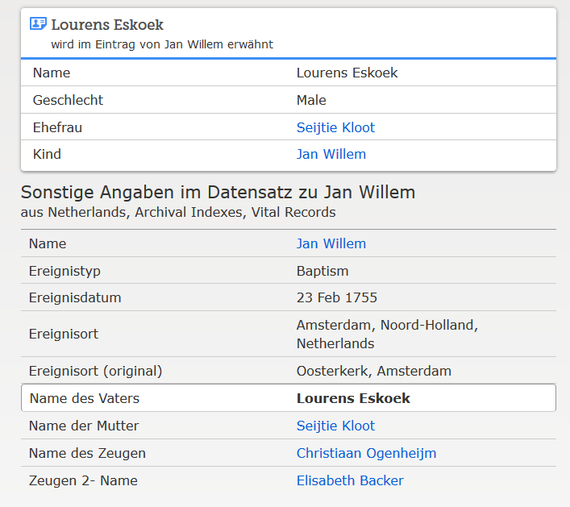

www.familysearch.org ; Jan Willem (II.) Eskoek, Taufe 1755

