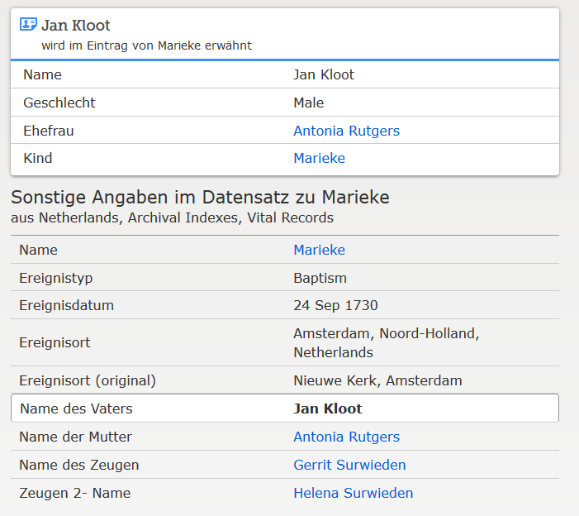

www.familysearch.org ; Marieke, Taufe 1730

