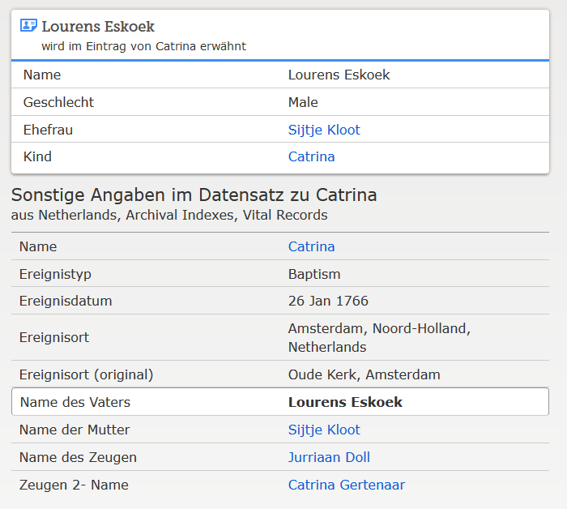

www.familysearch.org ; Catrina Eskoek, Taufe 1766

