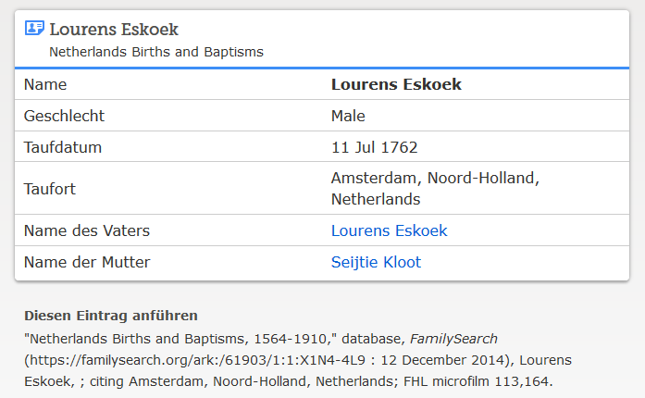

www.familysearch.org ; Lourens (III.) Eskoek, Taufe 1762

