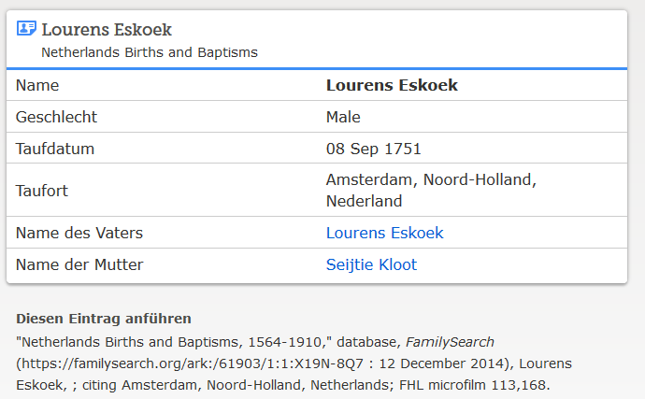

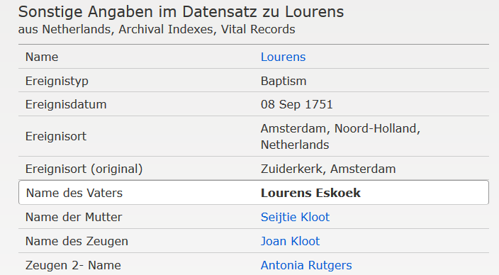

www.familysearch.org ; Lourens (II.) Eskoek, Taufe 1751

