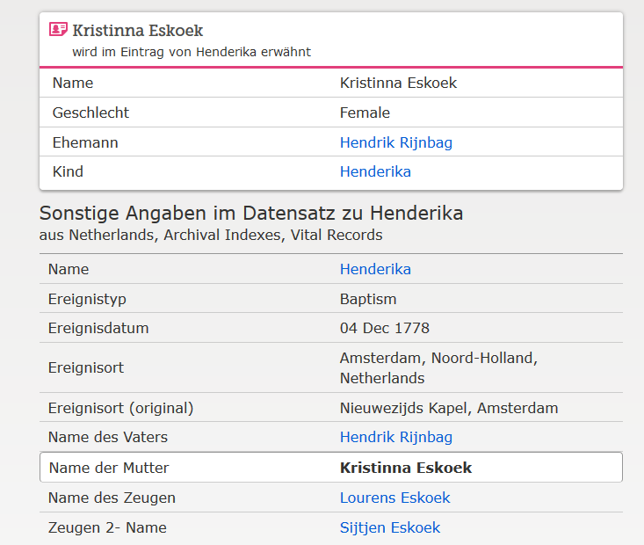

www.familysearch.org; Henderika Eskoek, Taufe 1778

