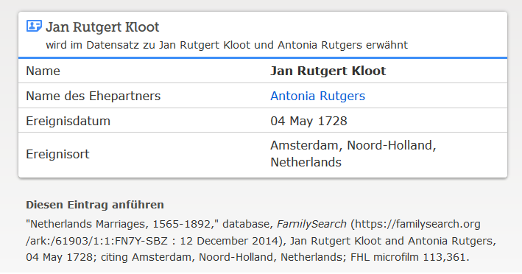

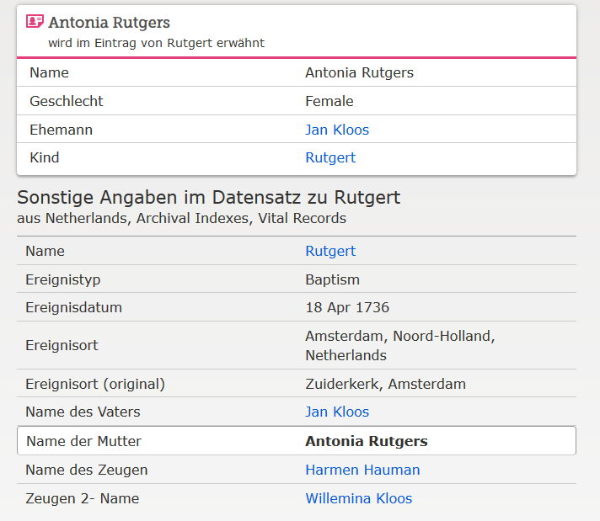

[www.familysearch.org](http://www.Familysearch.org); Rutgert Kloot, Taufe 1736