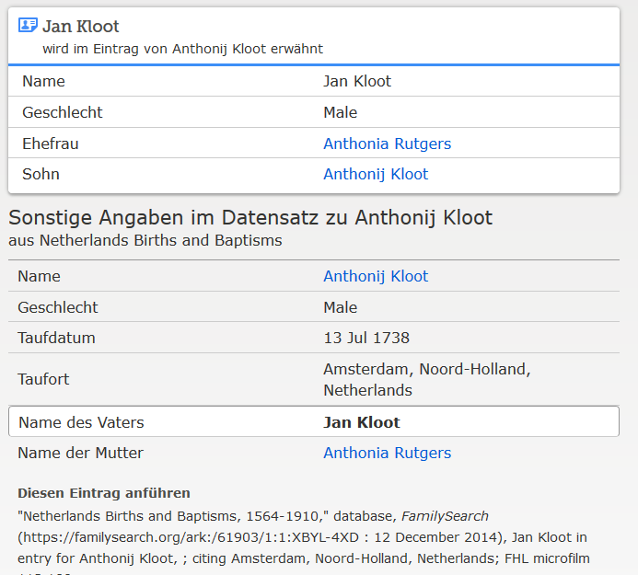

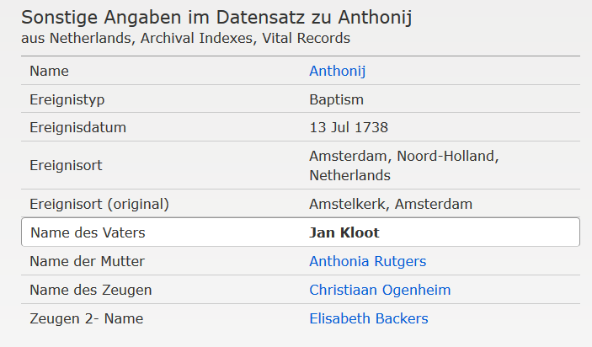

[www.familysearch.org](http://www.familysearch.org) ; Anthonij Kloot, Taufe 1738