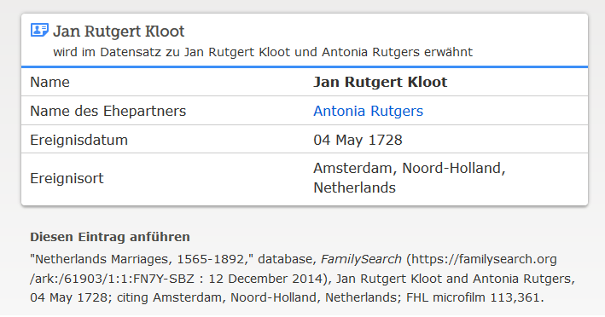

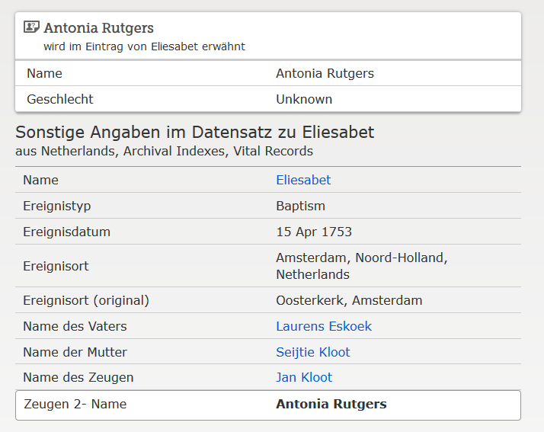

[www.familysearch.org](http://www.Familysearch.org); Eliesabet Eskoek, Taufe 1753