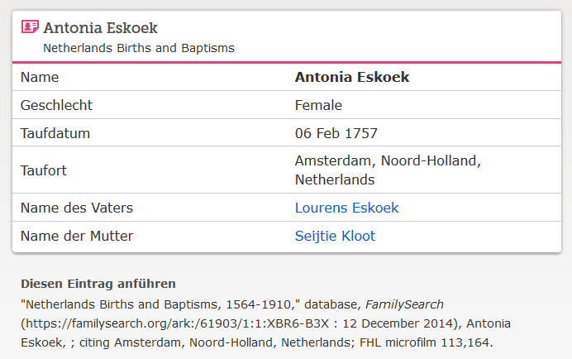

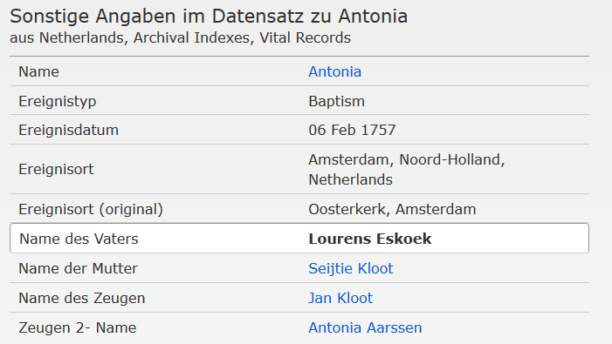

[www.familysearch.org](http://www.familysearch.org) ; Antonia Eskoek, Taufe 1757